

DOCUMENTACIÓN BASE DE DATOS

 Estudiante:

 David Felipe Alfonso Espinosa

 Docente:

 Andrés Daza

Materia:

 Aplicaciones de Bases de datos

 Institución Universitaria de Colombia

Programa: Ingeniería de Sistemas

 Bogotá D.C

2023

**MODELO LÓGICO:**

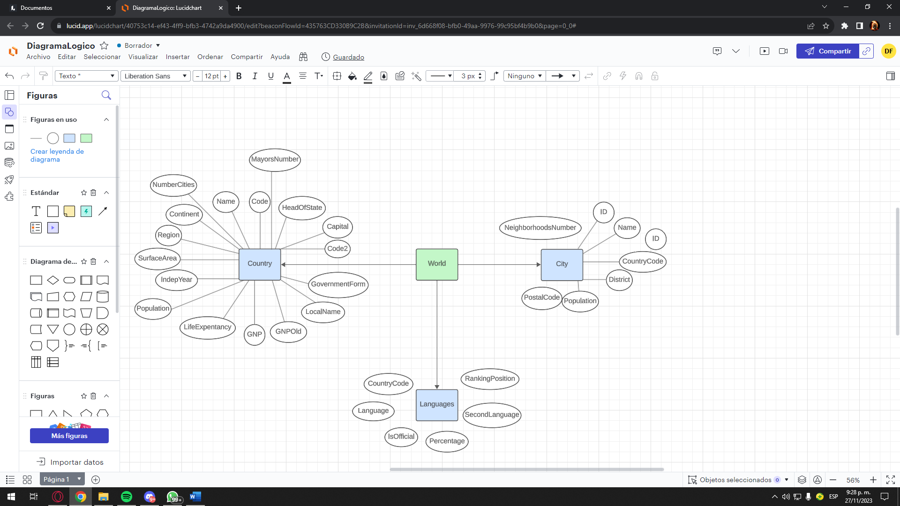

**DIAGRAMA ENTIDAD RELACIÓN:**

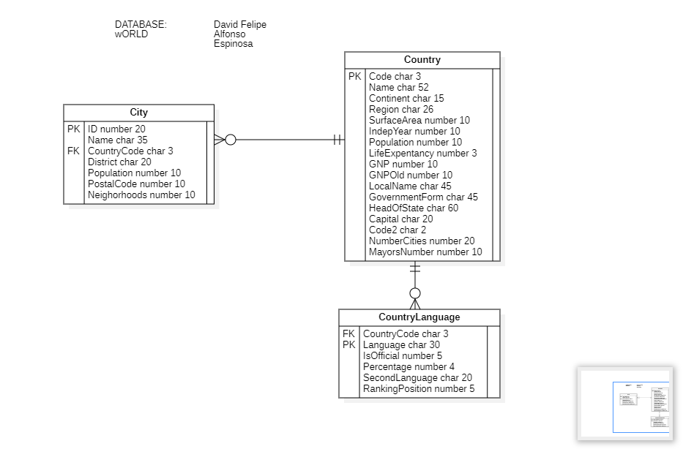

**DOCUMENTACIÓN EN PHP:**

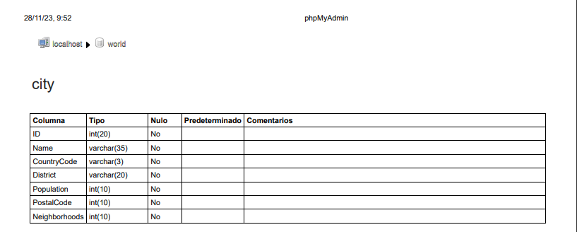  
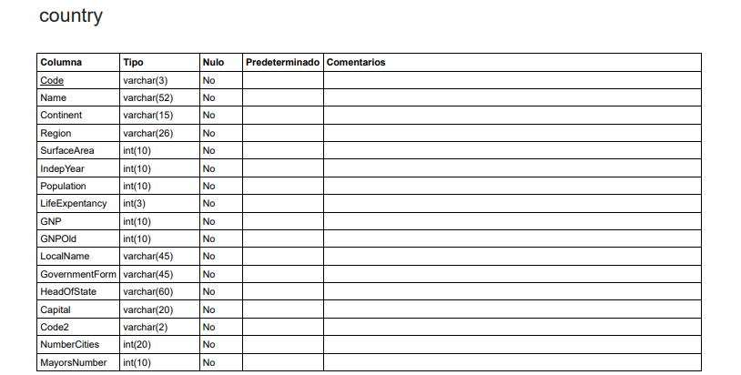

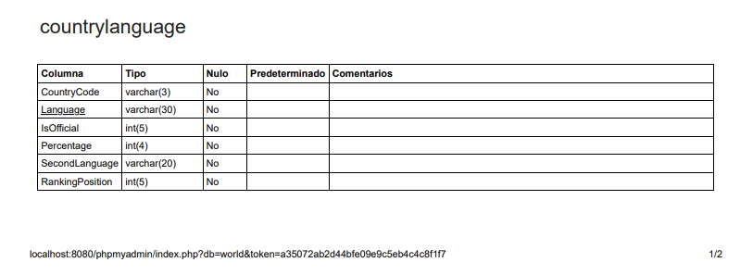

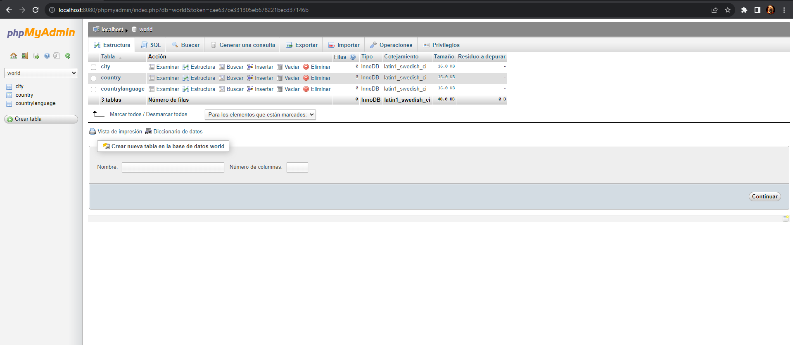

**DICCIONARIO DE DATOS:**

|  |  |  |  |  |
| --- | --- | --- | --- | --- |
| **CAMPO** | **LLAVE** | **TIPO DATO** | **NULL** | **DESCRIPCIÓN** |
| ID | PK | number, 20 | not null | Id de la ciudad |
| Name |  | char, 35 | not null | City name |
| CountryCode | FK | char, 3 | not null | Code of the country where the city is located |
| District |  | char, 20 | not null | District of the city |
| Population |  | char, 20 | not null | Total population of the city |
| PostalCode |  | number, 20 | not null | Number of the Postal Code |
| NeighborhoodsNumber |  | number, 20 | not null | Total neighborhoods number of the city |
| Code | PK | char, 3 | not null | Country Code |
| Name |  | char, 52 | not null | Country name |
| Continent |  | number, 10 | not null | Continent where the country is |
| Region |  | char, 26 | not null | Wold region where the country is |
| SurfaceArea |  | number, 10 | not null | Total Surface area |
| IndepYear |  | number, 10 | not null | Independence year |
| Population |  | number, 10 | not null | Total population |
| LifeExpentancy |  | number, 3 | not null | Population life expentancy |
| GNP |  | number, 10 | not null |  |
| GNPOld |  | number, 10 | not null |  |
| LocalName |  | char, 45 | not null | Country local name |
| GovernmentForm |  | char, 45 | not null | Country government form |
| HeadOfState |  | char, 60 | not null | Country head of state |
| Capital |  | char, 20 | not null | Country capital |
| Code2 |  | char, 2 | not null |  |
| NumberCities |  | number, 20 | not null | Total cities number |
| MayorsNumber |  | number, 10 | not null | Total mayors number |
| CountryCode | FK | char, 3 | not null | Codeo f the country where the language is talked |
| Language | PK | char, 30 | not null | Language name |
| IsOfficial |  | char, 10 | not null | Say if the language is oficial in this country or not |
| Percentage |  | number, 4 | not null | Percentage of people who talk this language |
| SecondLanguage |  | char, 30 | null | Second language of the country, if the country have one |
| RankingPosition |  | number, 5 | not null | Ranking position of the language |